EE3060 Probability – Proposed questions and answers

Question 1:

Let X and Y be random variables with finite expectations. Show that if P(X≦Y)=1, then E(X) ≦ E(Y).

Answer 1:

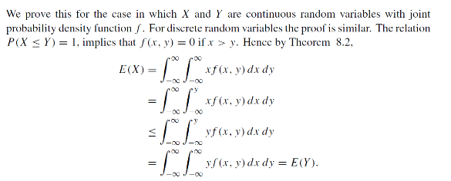

Question 2:

Using MGFs prove that if X∼Binomial(m,p) and Y∼Binomial(n,p) are independent, then X+Y∼Binomial(m+n,p).

Answer 2:

Question 3:

Let $θ$ be a random number from 0 to $2π$. $X=\sin{θ and} Y=\cos{θ}$ be random variables, please prove that X and Y are uncorrelated.

Answer 3:

The PDF of $θ$ is given by $f_{θ}=\left\{\begin{aligned}\frac{1}{2π} if 0≤θ≤2π \\ 0 otherwise\end{aligned}\right.$

Therefore,

$$E\left(XY\right)=\int_{0}^{2π}{\sin{θ}\cos{θ}\frac{1}{2π}}dθ=0$$

$$E\left(X\right)=\int_{0}^{2π}{\sin{θ}\frac{1}{2π}}dθ=0$$

$$E\left(Y\right)=\int_{0}^{2π}{\cos{θ}\frac{1}{2π}}dθ=0$$

Thus $Cov\left(X,Y\right)=E\left(XY\right)-E\left(X\right)E\left(Y\right)=0$.

Uncorrelated.

Question 4:

Let X,Y and Z be three jointly continuous random variables with joint PDF

$f_{x,y,z}\left(x,y,z\right)=c\left(x+2y+3z\right) 0_{-}^{<} x,y,z {}_{-}^{<}1$

=0 , otherwise

1. Find the constant c.
2. Find the marginal PDF of X.

Answer 4:

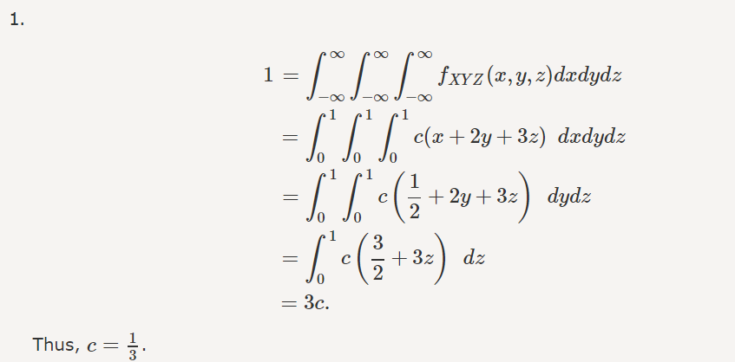

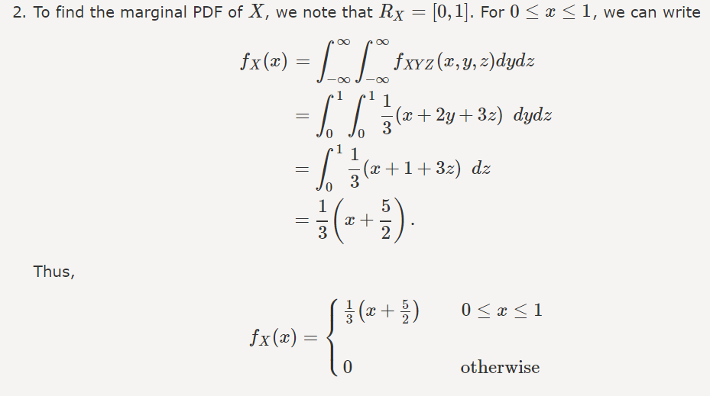

Question 5:

Cards are drawn from an ordinary deck of 52, one at a time, randomly and with replacement. Let X and Y denote the number of draws until the first ace and the first king are drawn, respectively. Find E(X|Y=5).

Answer 5:

